**Basic Electric Circuits Module 01**

**Basic Circuit Elements and Waveforms Lecture-03**

**Circuit Elements Part-1 By**

**Professor Ankush Sharma Department Electrical Engineering**

**Indian Institute of Technology, Kanpur**

(Refer Slide Time: 00:39)

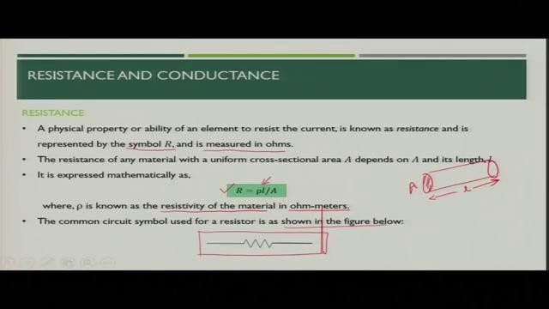

Namaskar, so today we will discuss about the various circuit elements in this lecture. Basically, the major passive elements in our electrical circuits are resistor, capacitor, and inductor. So, today we will discuss the various properties of resistors, capacitors, and inductors. Let us start with the first element called resistor. So, let see what see what is resistance? Resistance is a physical property or ability of an element to resist the current. So, basically whenever the current flows in a particular element it tries to oppose the flow of current. So, that property of the element is called resistance.

Now, how you will represent this resistance? The symbol is R. So, generally you will see that in the literature, the symbol R is most commonly used for the resistance and it is measured in ohms. Resistance of any material is dependent on the area as well as length of the element. So, basically if you see cross section of a particular element of area A and length l, the resistance of that particular element is given by 𝑅 = 𝜌𝑙/𝐴. It means 𝜌 would be the resistivity of the material which is represented in ohm meters, the length of the element, and cross-sectional area

of that element. So, these two are the properties of that element which together with the resistivity of the material will define what is the value of resistances of that element. So, in common circuit elements, resistance is one of the most common and you will see that in the various literature and books, you will see this kind of figure represented for the resistance.

(Refer Slide Time: 02:38)

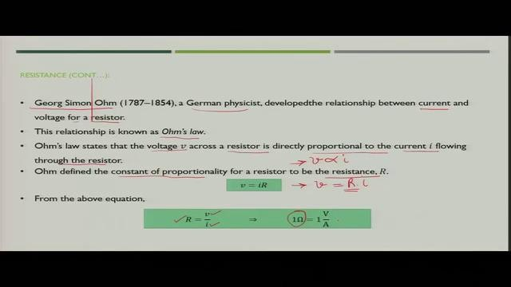

How did the resistance property come into the literature? George Simon Ohm was the German physicist who developed the relationship between current and voltage for a resistor. This relationship is called as Ohms law, which was given by the German physicist. Now, what does Ohm’s law say? Ohm’s law says that, the voltage V across a particular resistor is directly proportional to the current I, which is flowing through that resistor. So, you can simply represent that V is directly proportional to current I.

Now, Ohm define one constant, which is called proportionality constant for this particular equation and that was represented by R and from there the equation came 𝑉 = 𝑖𝑅. So, this proportionality constant was the resistance of that element through which the current is flowing. So, now from the above equation you can simply say that resistance R is nothing but, voltage V divided by current. So, for 1 Ohm, what you will say? You will say 1 Ohm is nothing but 1 Volt per Ampere.